EEE-4020 EMBEDDED SYSTEMS

DIGITAL ASSIGNMENT-2

TEAM MEMBERS:

M. MATHEESH (20BEE0021)

SAI VIJAY BK (20BEI0052)

QN.8

DEMONSTRATE THE MODBUS COMMUNICATION PROTOCOL

**Aim:**

To demonstrate the modbus protocol and how it works using STM32 and Simply Modbus Slave software.

**Theory:**

RS-485 is a standard for serial communication in telecommunications systems, mainly used for industrial automation and control systems. It is a half-duplex communication protocol that enables reliable communication between multiple devices over long distances  at high speeds. RS-485 uses a differential signaling system, where data is transmitted over two wires with opposite polarity to reduce electromagnetic interference and improve noise immunity.

Modbus is a communication protocol widely used in industrial automation and control systems.Modbus uses a client-server model, where a master device (the client) requests data or performs actions from one or more slave devices (the server). The master device sends requests to the slave devices using a standard message format, which includes the slave address, function code, data, and error checking information. However, it should never be confused with a medium of communication. MODBUS only forms the messaging structure, but is not the physical medium of data transmission.

**Basics of RS485:**

In RS485 standard, data is transmitted via two wires twisted together also referred to as "Twisted Pair Cable". The twisted pairs in RS485 provide immunity to electrical noise, making it suitable for use in electrically noisy environments.

With two wires at its core, RS485 allows for half-duplex data transmission. This means that data can be transmitted in both directions, one direction at a time, to and from devices. By adding two more wires, making the system four wires, data can be transmitted in both directions to and from devices at the same time, also known as full-duplex. In a full-duplex setup, however, they are limited to master and slave communication, with slaves unable to communicate with one another.

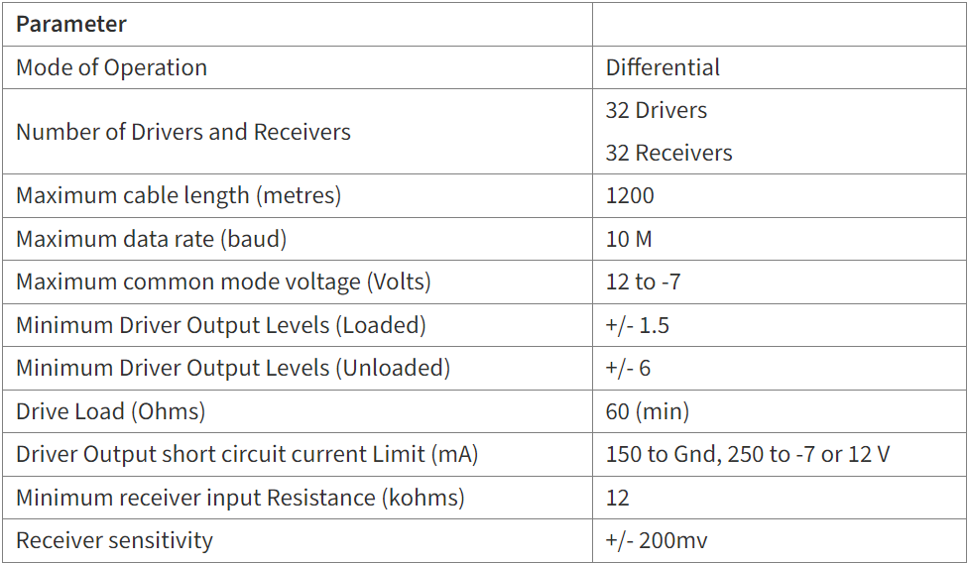

**Basics of MODBUS:**

MODBUS is a method for sending data over serial lines between electronic devices. The device requesting information is known as a Modbus Client (or Master), while the devices supplying information are known as Modbus Servers (or Slave). A typical MODBUS network has one Client and up to 247 Servers, each with a unique Server Address ranging from 1 to 247. In addition to requesting information, the Client can also write data to the Servers. MODBUS has evolved into an industry standard communications protocol and is now the most widely used method of connecting industrial electronic devices. It is widely used by many manufacturers across a wide range of industries. Modbus is commonly used to send data from control devices back to the main controller.

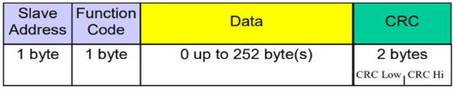

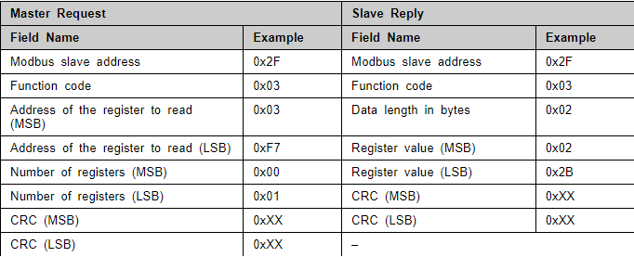

**Connection Diagram:**

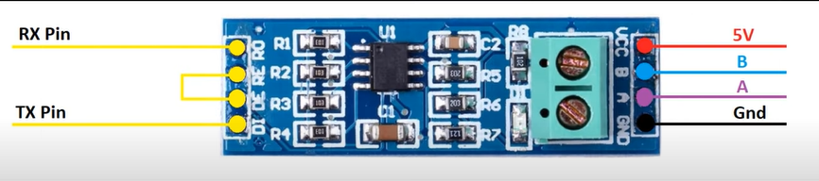

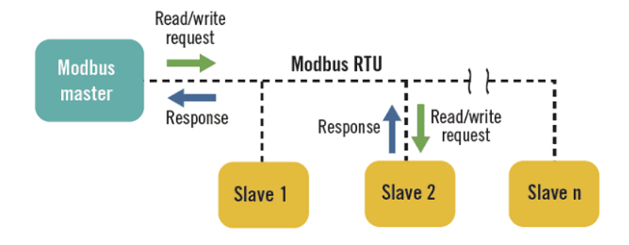

**Setup:**

